QUANTCAST CRP EBS 12.2.9 Upgrade DBA Playbook

Document Control

Change Record

Date | Author | Version | Change Reference

Reviewers

Name | Position

- The copy numbers referenced above should be written into the Copy Number space on the cover of each distributed copy. If the document is not controlled, you can delete this table, the Note To Holders, and the Copy Number label from the cover page.

Note To Holders:
If you receive an electronic copy of this document and print it out, please write your name on the equivalent of the cover page, for document control purposes.
If you receive a hard copy of this document, please write your name on the front cover, for document control purposes

Table of Contents
PRE-CUTOVER 3
PC1 – Take a backup of DB and RDBMS Home. 3
PC2 - Apply October 2020 PSU patch and ETCC patches 3
PC3 - Run ETCC on DB Tier 4
PC4 - Create staging as EBSCRP user 4
PC5 - Install 12.2 file system 5
PC6 - Install ETCC MT Patches 12
PC7 Update EBS 12.2 Parameters 13
MS1 - Milestone Backup 1 14
BACKUP 14
CB0 - Cold backup 14
CUTOVER 15
CU0 - Update DB parameters 15
CU1 - Apply AD CUP Patches 15
CU2 - Apply Pre-Install Patches 15
CU3 - Merge Upgrade Driver 15
CU4 - Disable Custom Triggers and Custom Jobs 16
CU5 - Apply 1220 Upgrade Driver 17
CU6 - Configure EBS 12.2 Filesystem 18
MS2 - Milestone Backup 2 19
ONLINE ENABLEMENT 20
OLE1 - Apply Online Patching Readiness and GSCC Report patches 20
OLE2 - Register Custom Schemas 20
OLE3 - Perform fix for AD_ZD_PREP invalid object 20
OLE4 - Ensure there are no AD_ZD invalid objects 20
OLE5 - Apply the Online Patching Enablement patch 21
OLE6 - Run ETCC 21
AD & TXK PATCHES 21
AT1 - Run adgrants.sql 21
AT2 - Start Weblogic Admin Server 21
AT3 - Drop ADX_PRE_AUTOCONFIG Table 21
AT4 - Apply AD.12 Patch 22
AT5 - Apply TXK.12 Merge patches 22
AT6 - Stop Weblogic Admin Server 22
AT7 - Migrate Latest Code to both the RAC nodes 22
AT8 - Build Context File on both the DB node 23
AT9 - Run Autoconfig on DB node 23
AT10 - Run Autoconfig on Apps Tier 23
MILESTONE BACKUP 3 23
12.2.9 UPGRADE 23
RUP1 - Apply 12.2.9 Upgrade Patch in Downtime Mode and Interactive Mode 23
RUP2 - Apply 1220 Online Help Patch 24
RUP3 - Apply 1229 Online Help Patch 24
RUP4 - Apply OA Framework (FWK) Release 12.2.9 Bundle 7 Patch 24
RUP5 - Apply EBS JAN 2021 CPU Patch 24
RUP6 - Apply Post patches 24
MILESTONE BACKUP 4 24
JDK UPGRADE 25
JDK1 - Main JDK Upgrade 25
JDK2 - Update JDK Configuration 25
JDK3 - Run autoconfig 25
JDK4 - WebTier JDK Upgrade - 64 Bit 25
JDK5 - 1012 Home JDK Upgrade-32 bit 25
JDK6 - Relink Forms 25
JDK7 - Relink Reports 25
JDK8 - Allow Unrestricted access for JSPs 26
JRE UPGRADE 26
JRE1 - Apply the JRE Interoperability Patch 26
JRE2 - Copy Latest JRE 26
JRE3 - Update JRE Configuration 26
Post Upgrade Steps 26
PUG1A - Update Context File for below parameters 26
PUG1 - Copy Custom tops from 1213 27
PUG2 - Prepare Custom Env File 27
PUG4 - Run Autoconfig 27
PUG5 - Upload Patch Context File to DB 28
PUG6 - Copy Logo Files 28
PUG7 - XDO Configuration 28
PUG8 - Perform ADADMIN Activities 28
PUG9 - Re-enable the Custom triggers 29
PUG9.1 - Custom JAR deployment – Not done in EBSCRP yet 30
PUG10 - Bring up Apps Services 31
PUG11 - Perform Sanity Tests 31
PUG12 - Run FS_CLONE 31
PUG13 - Run adpreclone on both Run and Patch FS 31
PUG14 - Take Full Instance Backup 31
HA Node Addition 32
NA01 - Start AdminServer on both Run and Patch FS 32
NA02 - Enable Passwordless SSH 32
NA03 - Enable Shared file system on primary node 32
NA04 - Prepare pairs file for second and third nodes 32
NA05 - Run adclonectx.pl on the uap52 and uap53 33
NA10 - Stop Admin Server (on run and patch) 33
NA13 - Run autoconfig in following sequence 34
NA14 - Bring up Services on both APP nodes 34
NA17 - Restart the services. 34
NA19 - Run fs_clone with all 3 APP nodes in place 34
NA20 - Run adpreclone.pl on both Run and Patch FS 34
NA21 - Compile Invalids 34
MS6 - Final Milestone Backup 34

EBS 12.2.9 Upgrade Steps

PRE-CUTOVER
*** EBSCRP application access
***

PC1 – Take a backup of DB and RDBMS Home.

Take OH backup as below

[oracrp@ebscrp 19c]$ pwd
/u03/oracle/crp/19c
- nohup tar -cvzf /stage/DB_APPS_BKP_P3/CRP/OH_BKP/OH_BEFORE_UPG_GOLD.tgz dbhome_1>/stage/DB_APPS_BKP_P3/CRP/OH_BKP/CRP_BEFORE_UPG_GOLD_OHBKP.log &

- STARTUP MOUNT

[oracrp@ebscrp DB_APPS_BKP_P3]$ pwd
/stage/DB_APPS_BKP_P3

Execute RMAN BACKUP as below

[oracrp@ebscrp DB_APPS_BKP_P3]$ nohup sh rman_bkp_PC1.sh >/stage/DB_APPS_BKP/CRP/DB/rman_full_bkp_CRP_20210828_FINAL_nh.log &

[oracrp@ebscrp DB_APPS_BKP_P3]$ cat rman_bkp_final.sh
echo "Backup start time is `date` " >> /stage/DB_APPS_BKP_P3/CRP/rman_full_bkp_CRP_20210828_ PC1.log
rman target / > /stage/DB_APPS_BKP_P3/CRP/rman_full_bkp_CRP_20210828_FINAL.log << EOF
run {
allocate channel ch1 type disk format '/stage/DB_APPS_BKP_P3/CRP/DB/dbfull_CRP_incr0_20210828_%d_t%t_s%s_p%p';
allocate channel ch2 type disk format '/stage/DB_APPS_BKP_P3/CRP/DB/dbfull_CRP_incr0_20210828_%d_t%t_s%s_p%p';
allocate channel ch3 type disk format '/stage/DB_APPS_BKP_P3/CRP/DB/dbfull_CRP_incr0_20210828_%d_t%t_s%s_p%p';
allocate channel ch4 type disk format '/stage/DB_APPS_BKP_P3/CRP/DB/dbfull_CRP_incr0_20210828_%d_t%t_s%s_p%p';
allocate channel ch5 type disk format '/stage/DB_APPS_BKP_P3/CRP/DB/dbfull_CRP_incr0_20210828_%d_t%t_s%s_p%p';
allocate channel ch6 type disk format '/stage/DB_APPS_BKP_P3/CRP/DB/dbfull_CRP_incr0_20210828_%d_t%t_s%s_p%p';
allocate channel ch7 type disk format '/stage/DB_APPS_BKP_P3/CRP/DB/dbfull_CRP_incr0_20210828_%d_t%t_s%s_p%p';
allocate channel ch8 type disk format '/stage/DB_APPS_BKP_P3/CRP/DB/dbfull_CRP_incr0_20210828_%d_t%t_s%s_p%p';
allocate channel ch9 type disk format '/stage/DB_APPS_BKP_P3/CRP/DB/dbfull_CRP_incr0_20210828_%d_t%t_s%s_p%p';
allocate channel ch10 type disk format '/stage/DB_APPS_BKP_P3/CRP/DB/dbfull_CRP_incr0_20210828_%d_t%t_s%s_p%p';
backup incremental level 0 section size 10G database
filesperset 5
include current controlfile;
backup current controlfile FORMAT '/stage/DB_APPS_BKP_P3/CRP/DB/cffull_CRP_20210828_d%d_t%t_s%s_p%p';
}
EOF
echo "Backup end time is `date` " >> /stage/DB_APPS_BKP_P3/CRP/DB/rman_full_bkp_CRP_20210828_PC1.log

IMP : During Rman backup if u see anything taking control backup,
[oracrp@ebscrp DB]$ cp -rp /u12/oracle/CRP/19c/dbhome_1/dbs/c-2456528033-20210706-00 .

Take Application folder tar backup as below

[applcrp@ebscrp CRP]$ pwd
/u01
- nohup tar -cvzf /stage/DB_APPS_BKP_P3/CRP/APP/CRP_BEFORE_UPG_GOLD.tgz crp > /stage/DB_APPS_BKP_P3/CRP/CRP_BEFORE_UPG_GOLD.log

PC2 - Apply JAN 2021 PSU patch and ETCC patches

APPLIED JAN2021 PSU to Database and APPLICATION Already on JAN 2021 PSU

Running EURC-DT:
==============
[oracrp@ebscrp patches]$ pwd
/stage/ETCC/patches
[oracrp@ebscrp patches]$ mkdir CRP_ETCC
-rwxr-x--- 1 oracrp dba 41K Jun 25 13:16 p32288423_R12_GENERIC.zip
drwxr-x--- 2 oracrp dba 6.0K Jun 25 13:17 CRP_ETCC
[oracrp@ebscrp patches]$ chmod -R 777 CRP_ETCC/

cd /stage/ETCC/consolidated_DB_FIXES/etcc-bundle/LINUX_X86-64/database/19.10.0.0.210119DBRU/
[oracrp@EBSCRP 19.10.0.0.210119DBRU]$ ls -lrth
total 2.7M
-r--r--r-- 1 oracrp dba 1020K Dec 18 05:40 p31424070_1910000DBRU_Generic.zip
-r--r--r-- 1 oracrp dba 209K Dec 19 11:01 p31405300_1910000DBRU_Linux-x86-64.zip
-r--r--r-- 1 oracrp dba 1.1M Dec 19 16:15 p28318139_1910000DBRU_Generic.zip
-r--r--r-- 1 oracrp dba 371K Jan 11 01:00 p29867728_1910000DBRU_Linux-x86-64.zip
[oracrp@EBSCRP 19.10.0.0.210119DBRU]$ unzip p31424070_1910000DBRU_Generic.zip

[oracrp@EBSCRP 19.10.0.0.210119DBRU]$unzip p31405300_1910000DBRU_Linux-x86-64.zip

cd 31424070
$ORACLE_HOME/OPatch/opatch apply

cd ../ 31405300
$ORACLE_HOME/OPatch/opatch apply

$ORACLE_HOME/OPatch/opatch lspatches

Run Datapatch:
===============

SQL> startup
cd $ORACLE_HOME/Opatch
./datapatch

PC3 - Run ETCC on DB Tier

- Copy the DB context file from existing home directory and change the ORACLE_HOME entries

cd /backup/EBSCRP/patches/ETCC
./checkDBpatch.sh contextfile=/u12/oracle/CRP/19c/dbhome_1/appsutil/CRP_ebscrp.xml

PC4 - Create staging as EBSCRP user

[applcrp@ebscrp build]$ unzip p22066363_R12_GENERIC.zip 🡺 StartCD
[applcrp@ebscrp build]$ pwd
/stage/build

[applcrp@ebscrp build]$ cd startCD/Disk1/rapidwiz/bin
[applcrp@ebscrp bin]$ ./buildStage.sh

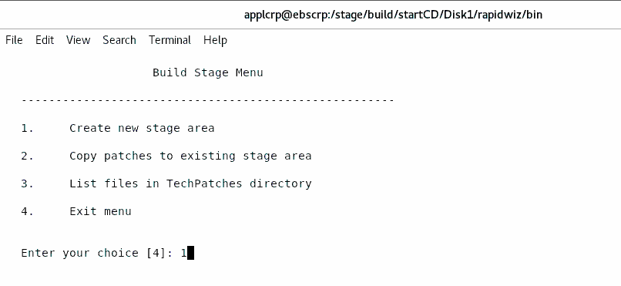

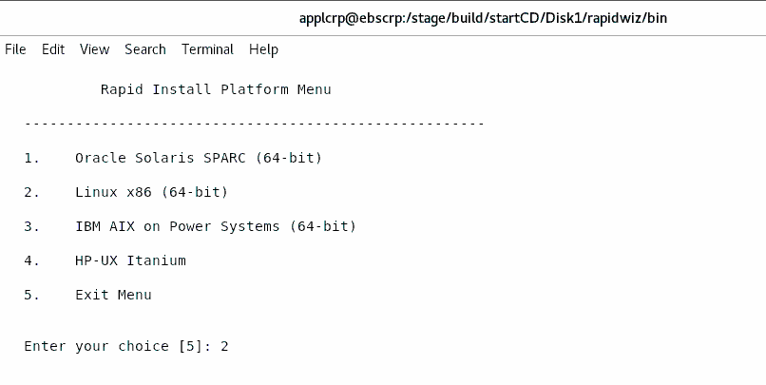

Specify the directory containing the zipped installation media:
/stage/build

[applcrp@ebscrp 25525148]$ sh patchRIStage.sh
Patch directory is /stage/build/25525148

Enter the location of the Rapid Install Stage area:/stage/build

Completed patching of the Rapid Install Stage area /stage/build
[applcrp@ebscrp 25525148]$

[applcrp@ebscrp build]$ cd 31033613/
[applcrp@ebscrp 31033613]$

[applcrp@ebscrp 31033613]$ sh patchRIStage.sh
Patch directory is /stage/build/31033613

Enter the location of the Rapid Install Stage area:/stage/build
[applcrp@ebscrp 31033613]$

PC5 - Install 12.2 file system

echo $DISPLAY

sudo su - EBSCRP

[applcrp@ebscrp ~]$ cd /stage/build/startCD/Disk1/rapidwiz/
[applcrp@ebscrp rapidwiz]$ ./rapidwiz

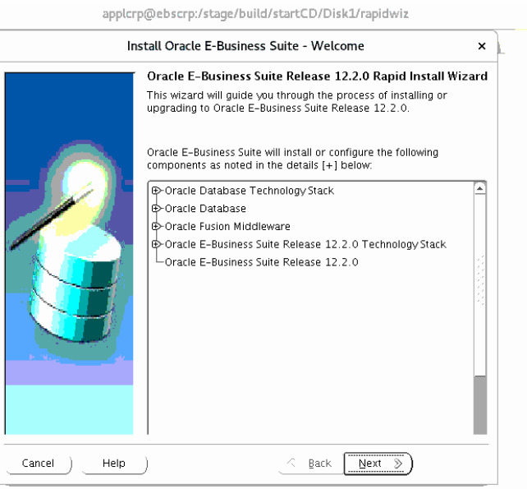

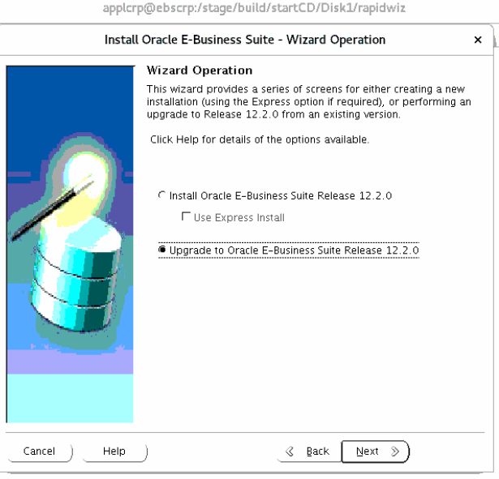

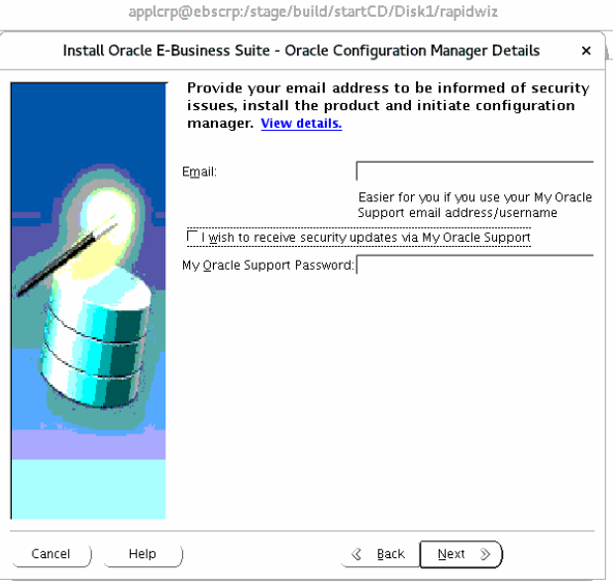

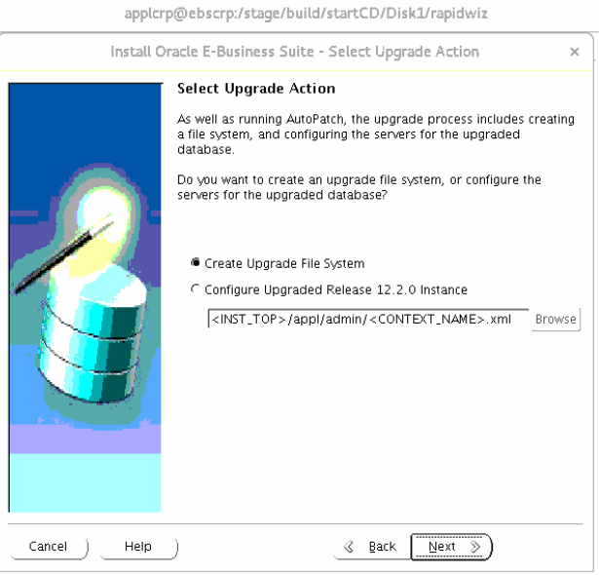

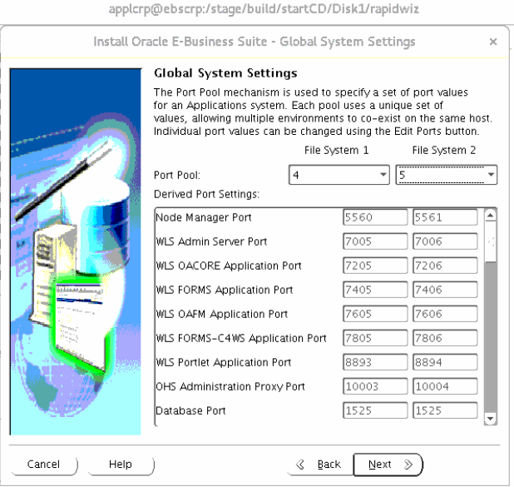

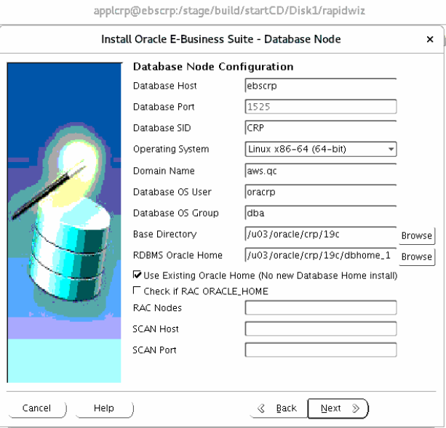

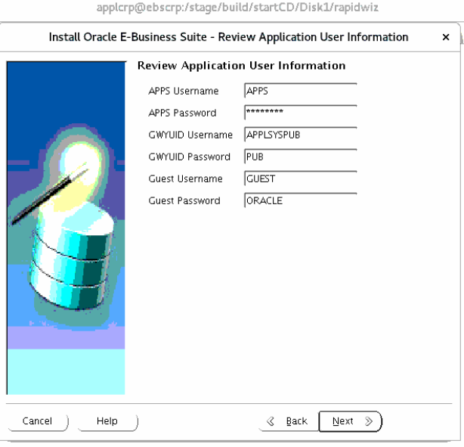

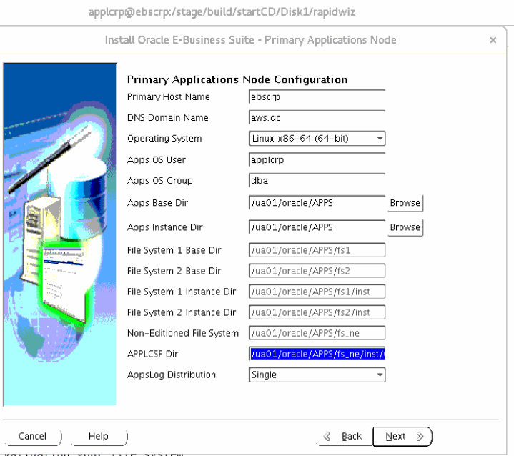

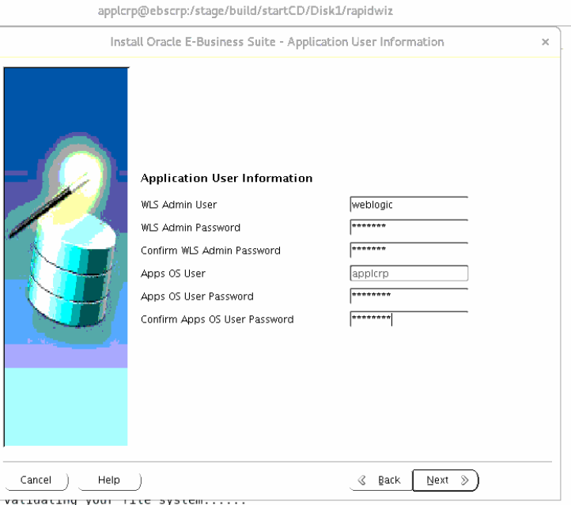

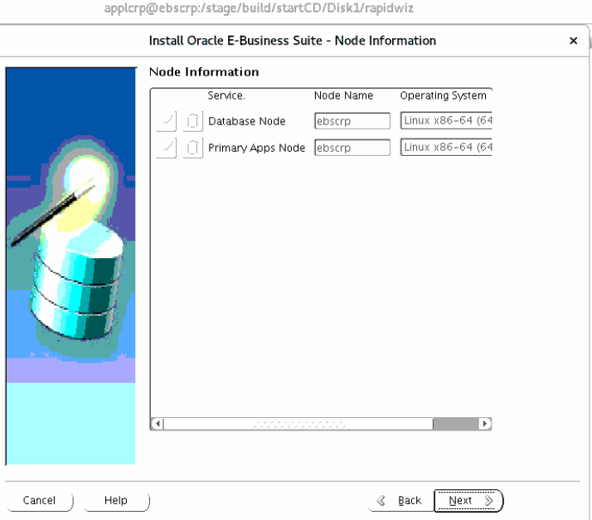

SQL> alter system set service_names='CRP','ebs_patch','EBSCCDB';

System altered.

SQL> show parameter service

NAME TYPE VALUE
------------------------------------ ----------- ------------------------------
service_names string CRP, ebs_patch, EBSCCDB

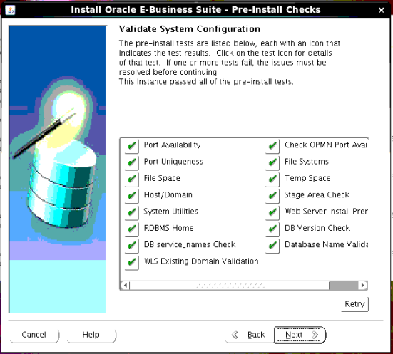

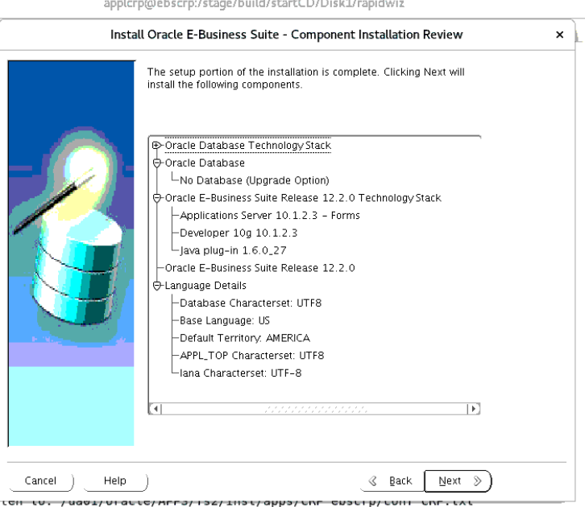

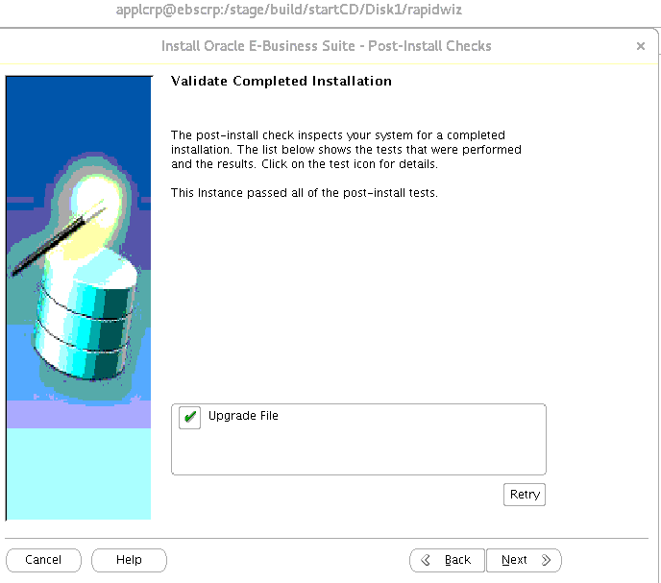

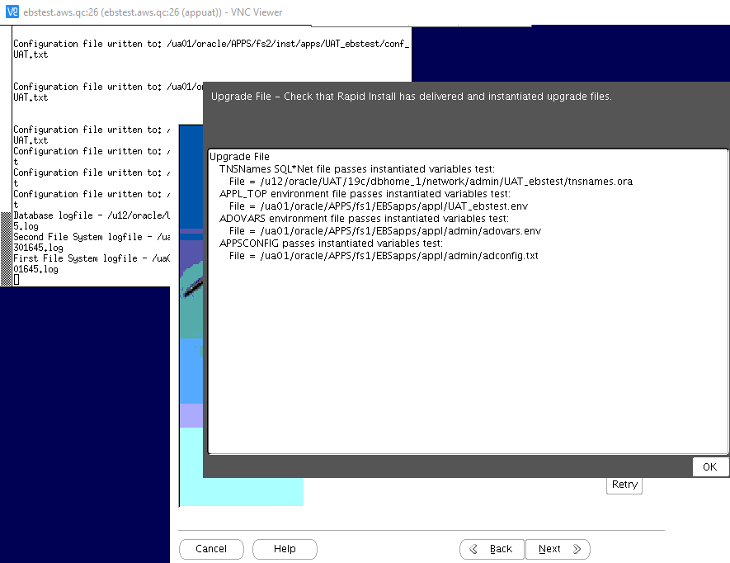

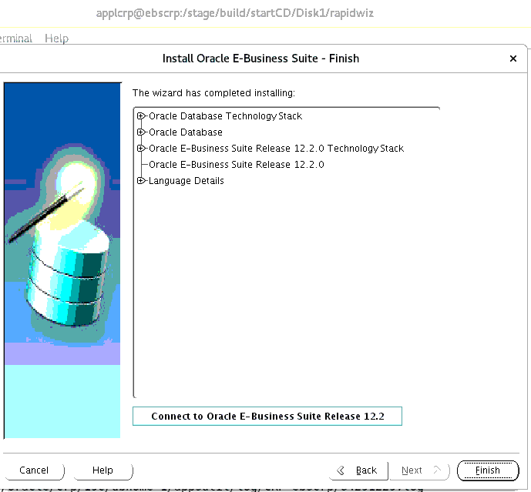

PC6 - Install ETCC MT Patches
cd /stage/ETCC/consolidated_12.2_JAN21

Forms Patching

cd /stage/ETCC/consolidated_12.2_JAN21/etcc-bundle/LINUX_X86-64/forms/10.1.2.3.0/26825525
$ORACLE_HOME/OPatch/opatch apply

cd ../25342269
$ORACLE_HOME/OPatch/opatch apply

cd ../27491934
$ORACLE_HOME/OPatch/opatch apply

FMW Web Tier patching

export ORACLE_HOME=/ua01/oracle/APPS/fs1/FMW_Home/webtier
export PATH=$ORACLE_HOME/OPatch:$PATH

cd /stage/ETCC/consolidated_12.2_JAN21/etcc-bundle/LINUX_X86-64/webtier/11.1.1.9.0/22288381
$ORACLE_HOME/OPatch/opatch apply

cd /stage/ETCC/consolidated_12.2_JAN21/etcc-bundle/LINUX_X86-64/webtier/11.1.1.9.0/31047338
$ORACLE_HOME/OPatch/opatch apply

cd /stage/ETCC/consolidated_12.2_JAN21/etcc-bundle/LINUX_X86-64/webtier/11.1.1.9.0/31304503
$ORACLE_HOME/OPatch/opatch apply

cd /stage/ETCC/consolidated_12.2_JAN21/etcc-bundle/LINUX_X86-64/webtier/11.1.1.9.0/23716938
$ORACLE_HOME/OPatch/opatch apply

RSF within FMW Web tier Patching

cd /stage/ETCC/consolidated_12.2_JAN21/etcc-bundle/LINUX_X86-64/webtier/11.1.0.7.0/22290164
$ORACLE_HOME/OPatch/opatch apply

ORACLE_COMMON Patching

export ORACLE_HOME=/ua01/oracle/APPS/fs1/FMW_Home/oracle_common
export PATH=$ORACLE_HOME/OPatch:$PATH

cd /stage/ETCC/consolidated_12.2_JAN21/etcc-bundle/LINUX_X86-64/oracle_common/11.1.1.9.0/9905685/oui
$ORACLE_HOME/OPatch/opatch apply

cd /stage/ETCC/consolidated_12.2_JAN21/etcc-bundle/LINUX_X86-64/oracle_common/11.1.1.9.0/17428617
$ORACLE_HOME/OPatch/opatch apply

cd /stage/ETCC/consolidated_12.2_JAN21/etcc-bundle/LINUX_X86-64/oracle_common/11.1.1.9.0/21366277
$ORACLE_HOME/OPatch/opatch apply

cd /stage/ETCC/consolidated_12.2_JAN21/etcc-bundle/LINUX_X86-64/oracle_common/11.1.1.9.0/21628307
$ORACLE_HOME/OPatch/opatch apply

cd ../24606362
$ORACLE_HOME/OPatch/opatch apply

cd ../24843064/oui
$ORACLE_HOME/OPatch/opatch apply

cd ../../13544814
$ORACLE_HOME/OPatch/opatch apply

cd ../16089637
$ORACLE_HOME/OPatch/opatch apply

cd ../20141119
$ORACLE_HOME/OPatch/opatch apply

cd ../30368663/oui
$ORACLE_HOME/OPatch/opatch apply

cd ../../27212806
$ORACLE_HOME/OPatch/opatch apply

cd ../28708563
$ORACLE_HOME/OPatch/opatch apply

WLS Patching
cd $FMW_HOME/utils/bsu
unzip /stage/ETCC/consolidated_12.2_JAN21/etcc-bundle/LINUX_X86-64/WLS_JAN2021_PSU/p31136426_1036_Generic.zip
chmod 755 bsu_update.sh
./bsu_update.sh install

cp bsu.sh bsu.sh_bkp
vi bsu.sh
Update MEM_ARGS to below value:
MEM_ARGS="-Xms4098m -Xmx4098m -XX:-UseGCOverheadLimit"

cd $FMW_HOME/utils/bsu/cache_dir

unzip /stage/ETCC/consolidated_12.2_JAN21/etcc-bundle/LINUX_X86-64/WLS_JAN2021_PSU/p32052267_1036_Generic.zip

cd $FMW_HOME/utils/bsu/
./bsu.sh -install -patch_download_dir=/ua01/oracle/APPS/fs1/FMW_Home/utils/bsu/cache_dir -patchlist=1YWL -prod_dir=/ua01/oracle/APPS/fs1/FMW_Home/wlserver_10.3 -log=wlsjan21psu_1YWL.log
./bsu.sh -remove -patchlist=1LRI,2GYW,CW9T,VKXF,BLTG -prod_dir=/ua01/oracle/APPS/fs1/FMW_Home/wlserver_10.3 -log=Wlsremb4jan21psu_1YWL_1.log
./bsu.sh -remove -patchlist=YHJK,FCX7,Y5AP -prod_dir=/ua01/oracle/APPS/fs1/FMW_Home/wlserver_10.3 -log=Wlsremb4jan21psu_1YWL_2.log
./bsu.sh -install -patch_download_dir=/ua01/oracle/APPS/fs1/FMW_Home/utils/bsu/cache_dir -patchlist=1YWL -prod_dir=/ua01/oracle/APPS/fs1/FMW_Home/wlserver_10.3 -log=wlsjan21psu_1YWL.log

unzip -o /stage/ETCC/consolidated_12.2_JAN21/etcc-bundle/LINUX_X86-64/wls/10.3.6.0.210119/p13845626_10360210119_Generic.zip
unzip -o /stage/ETCC/consolidated_12.2_JAN21/etcc-bundle/LINUX_X86-64/wls/10.3.6.0.210119/p22323006_1036_Generic.zip
unzip -o /stage/ETCC/consolidated_12.2_JAN21/etcc-bundle/LINUX_X86-64/wls/10.3.6.0.210119/p26795917_1036_Generic.zip

cd $FMW_HOME/utils/bsu/

./bsu.sh -prod_dir=$FMW_HOME/wlserver_10.3 -patchlist=CIH8 -remove -log=postjan21psuconflicts_postpatches.log
./bsu.sh -install -patch_download_dir=/ua01/oracle/APPS/fs1/FMW_Home/utils/bsu/cache_dir -patchlist=HJT5,DI8E,DN1F -prod_dir=/ua01/oracle/APPS/fs1/FMW_Home/wlserver_10.3 -log=wlsjan21psuoverlay_etcc_rcmd.log

Apply WLS ADR Patch

cd $FMW_HOME/utils/bsu/cache_dir
unzip -o /stage/ETCC/WLS_ADR_JULY2020/p31241365_1036_Linux-x86-64.zip

cd $FMW_HOME/utils/bsu/
./bsu.sh -patch_download_dir=/ua01/oracle/APPS/fs1/FMW_Home/utils/bsu/cache_dir -prod_dir=$FMW_HOME/wlserver_10.3 -patchlist=CW7X –install -log=adr_patch_july2020_rcmd.log

PC7 Update EBS 12.2 Context Parameters

  - Update .bash_profile in App server

. /ua01/oracle/APPS/fs1/EBSapps/appl/APPSCRP_ebscrp.env

  - Change the APPLPTMP,DBHOST and DBPORT to below in CONTEXT_FILE

[applcrp@ebscrp ~]$ cp /ua01/oracle/APPS/fs1/inst/apps/CRP_ebscrp/appl/admin/CRP_ebscrp.xml /ua01/oracle/APPS/fs1/inst/apps/CRP_ebscrp/appl/admin/CRP_ebscrp.xml_02July2021

[applcrp@ebscrp ~]$ grep -i s_applptmp $CONTEXT_FILE
<APPLPTMP oa_var="s_applptmp" osd="UNIX">/usr/tmp</APPLPTMP>

Changed as below in CONTEXT FILE
=====================================
[applcrp@ebscrp ~]$ grep -i s_applptmp $CONTEXT_FILE
<APPLPTMP oa_var="s_applptmp" osd="UNIX">/oratmp/CRP</APPLPTMP>

  - Update the ADJRIOPTS in the below files to -mx512m and NLS_LANG to American_America.AL32UTF8 ⇒ Already having 2GB. NO action Required

cd $INST_TOP/appl/admin
cp -pr adovars_CRP_ebscrp.env adovars_CRP_ebscrp.env_bkp_2jul21

< ADJRIOPTS="-mx512m"

vi $CONTEXT_FILE
<ADJRIOPTS oa_var="s_adjriopts" osd="LINUX_X86-64">-mx512m</ADJRIOPTS>

  - Update TNS IFILE

cd $TNS_ADMIN
vi CRP_ebscrp_ifile.ora

CRP = (DESCRIPTION=
(ADDRESS=(PROTOCOL=tcp)(HOST=ebscrp)(PORT=1538))
(CONNECT_DATA=(SID=CRP))
)

  - Check Custom triggers

SQL> select 'alter trigger '|| owner||'.'||trigger_name||' disable;' from dba_triggers where trigger_name like 'XX%' ;

'ALTERTRIGGER'||OWNER||'.'||TRIGGER_NAME||'DISABLE;'
--------------------------------------------------------------------------------
alter trigger APPS.XXQC_AR_BILLING_STG_T disable;

  - Check tablespace sizes and ensure free space of 5GB- APPS_TS_SEED and 25GB- SYSTEM

SQL> alter tablespace APPS_TS_SEED add datafile '/u14/oracle/CRP/CRPdata/a_ref05.dbf' size 5G;
Tablespace altered.
SQL> alter tablespace APPS_TS_SUMMARY add datafile '/u14/oracle/CRP/CRPdata/a_summ02.dbf' size 2G;
Tablespace altered.
SQL> alter tablespace APPS_TS_TX_DATA add datafile '/u14/oracle/CRP/CRPdata/a_txn_data07.dbf' size 10G;
Tablespace altered.
SQL> alter tablespace APPS_TS_TX_IDX add datafile '/u14/oracle/CRP/CRPdata/a_txn_ind09.dbf' size 10G;
Tablespace altered.
SQL> alter tablespace APPS_TS_TX_IDX add datafile '/u14/oracle/CRP/CRPdata/a_txn_ind10.dbf' size 10G;
Tablespace altered.
SQL> alter tablespace SYSAUX add datafile '/u14/oracle/CRP/CRPdata/sysaux07.dbf' size 20G;
Tablespace altered.
SQL> alter tablespace SYSTEM add datafile '/u14/oracle/CRP/CRPdata/system15.dbf' size 10G;
Tablespace altered.
SQL> alter tablespace XXQC_DATA add datafile '/u14/oracle/CRP/CRPdata/xxqc_data02.dbf' size 5G;
Tablespace altered.

  - Copy the wallet files, JAR signing cert and cacerts needed to /stage shared location on new app servers.
  - Copy the Custom tops and Concurrent Log and Out files.

MS1 - Milestone Backup 1

cd /ua4001/oracle/EBSCRP/
nohup tar -czvf /stage/backups/ua4001_EBSCRP_fs1_ms1.tar.gz fs1 &
nohup tar -czvf /stage/backups/ua4001_EBSCRP_fs2_ms1.tar.gz fs2 &
nohup tar -czvf /stage/backups/ua4001_EBSCRP_fsne_ms1.tar.gz fs_ne &

nohup tar -czvf /stage/backups/oraInventory_ms1.tar.gz oraInventory &

cd /ua4002/oracle/EBSCRP/
nohup tar -czvf /stage/backups/ua4002_EBSCRP_fs1_ms1.tar.gz fs1 &
nohup tar -czvf /stage/backups/ua4002_EBSCRP_fs2_ms1.tar.gz fs2 &

BACKUP

CB0 - Cold backup

*** Stop all the application / SSO services on existing server
*** Take the milestone backup

STARTUP MOUNT

[oracrp@ebscrp MS1]$cat rman_bkp_ms1_CRP.sh
echo "Backup start time is `date` " >> /stage/DB_APPS_BKP_P3/MS1/DB/rman_full_bkp_CRP_20210702_MS1.log
rman target / > /stage/DB_APPS_BKP_P3/MS1/DB/rman_full_bkp_CRP_20210702_MS1.log << EOF
run {
allocate channel ch1 type disk format '/stage/DB_APPS_BKP_P3/MS1/DB/dbfull_CRP_incr0_20210702_%d_t%t_s%s_p%p';
allocate channel ch2 type disk format '/stage/DB_APPS_BKP_P3/MS1/DB/dbfull_CRP_incr0_20210702_%d_t%t_s%s_p%p';
allocate channel ch3 type disk format '/stage/DB_APPS_BKP_P3/MS1/DB/dbfull_CRP_incr0_20210702_%d_t%t_s%s_p%p';
allocate channel ch4 type disk format '/stage/DB_APPS_BKP_P3/MS1/DB/dbfull_CRP_incr0_20210702_%d_t%t_s%s_p%p';
allocate channel ch5 type disk format '/stage/DB_APPS_BKP_P3/MS1/DB/dbfull_CRP_incr0_20210702_%d_t%t_s%s_p%p';
allocate channel ch6 type disk format '/stage/DB_APPS_BKP_P3/MS1/DB/dbfull_CRP_incr0_20210702_%d_t%t_s%s_p%p';
allocate channel ch7 type disk format '/stage/DB_APPS_BKP_P3/MS1/DB/dbfull_CRP_incr0_20210702_%d_t%t_s%s_p%p';
allocate channel ch8 type disk format '/stage/DB_APPS_BKP_P3/MS1/DB/dbfull_CRP_incr0_20210702_%d_t%t_s%s_p%p';
allocate channel ch9 type disk format '/stage/DB_APPS_BKP_P3/MS1/DB/dbfull_CRP_incr0_20210702_%d_t%t_s%s_p%p';
allocate channel ch10 type disk format '/stage/DB_APPS_BKP_P3/MS1/DB/dbfull_CRP_incr0_20210702_%d_t%t_s%s_p%p';
backup incremental level 0 section size 10G database
filesperset 5
include current controlfile;
backup current controlfile FORMAT '/stage/DB_APPS_BKP_P3/MS1/DB/cffull_CRP_20210702_d%d_t%t_s%s_p%p';
}
EOF
echo "Backup end time is `date` " >> /stage/DB_APPS_BKP_P3/MS1/DB/rman_full_bkp_CRP_20210702_MS1.log

CUTOVER

CU0 - Update DB parameters

alter system set recyclebin=off deferred;
alter system set optimizer_adaptive_features=false;
alter system set "_disable_actualization_for_grant"=true;
ALTER SYSTEM SET max_dump_file_size = unlimited scope=spfile;
ALTER SYSTEM SET "_system_trig_enabled"=TRUE;
alter system set service_names='EBSCRP','ebs_patch';
alter system set job_queue_processes=16 ;

alter system set DB_FLASHBACK_RETENTION_TARGET=43200 ;
alter system set db_recovery_file_dest_size=3000G ;
alter system set db_recovery_file_dest='+RECOC1' ;

ALTER PROFILE DEFAULT LIMIT FAILED_LOGIN_ATTEMPTS UNLIMITED;
ALTER PROFILE AD_PATCH_MONITOR_PROFILE LIMIT FAILED_LOGIN_ATTEMPTS UNLIMITED;
ALTER PROFILE EM_OAM_MONITOR_PROFILE LIMIT FAILED_LOGIN_ATTEMPTS UNLIMITED;
ALTER PROFILE GSM_PROF LIMIT FAILED_LOGIN_ATTEMPTS UNLIMITED;
ALTER PROFILE ORA_STIG_PROFILE LIMIT FAILED_LOGIN_ATTEMPTS UNLIMITED;

=====

CU1 - Apply AD CUP Patches

create table SYSTEM.invalids_CU1 as (select * from dba_invalid_objects);

Enable Maintenance mode

sqa @$AD_TOP/patch/115/sql/adsetmmd.sql ENABLE

cd /stage/scripts
sqlplus / as sysdba

EBSCRP> @adgrants.sql_CU1_69 APPS
EBSCRP> @?/rdbms/admin/utlrp

Grant execute on dbms_redefinition to APPS;
Cp /stage/ebs_patches/ADZDDTFIX/17268684/admin/ADZDDTFIX.sql /u12/oracle/CRP/19c/dbhome_1/appsutil/admin/

@ADZDDTFIX.sql
Execute the Generated SQL procedures as sysdba
###############################################
[applcrp@ebscrp AD_source]$ pwd
/stage/ebs_patches/AD_source

[applcrp@ebscrp AD_source]$ unzip "*.zip"
[applcrp@ebscrp AD_source]$ mkdir -p /stage/ebs_patches/10117518_CUP11
admrgpch -s /stage/ebs_patches/AD_source -d /stage/ebs_patches/10117518_CUP11 -merge_name 10117518_CUP11 -admode

time adpatch logfile=10117518_cup11.log patchtop=/stage/ebs_patches/10117518_CUP11 driver=u_10117518_CUP11.drv workers=8

Time taken : 35 MINS

POST STEP:
=========
Adadmin
Run adadmin -> Compile/Reload Applications Database Entities menu ->
Compile APPS schema.
2. Type "No" when prompt for Run Invoker Rights processing in incremental mode [No] ?

CU2 - Apply Pre-Install Patches

cd /stage/ebs_patches/Preinstall/30399970
time adpatch driver=u30399970.drv logfile=u30399970.log preinstall=y

cd ../ 31219447
time adpatch driver=u31219447.drv logfile=u31219447.log preinstall=y

cd ../31745734
time adpatch driver=u31745734.drv logfile=u31745734.log preinstall=y

CU3 - Merge Upgrade Driver

cd $AU_TOP/patch/115/driver
admrgpch -d . -preinstall -master u10124646.drv

CU4 - Disable Custom Triggers and Custom Jobs

Triggers:

select 'alter trigger '|| owner||'.'||trigger_name||' disable;' from dba_triggers where trigger_name like 'XX%' ;

sqa

SQL> select 'alter trigger '|| owner||'.'||trigger_name||' disable;' from dba_triggers where trigger_name like 'XX%' ;

'ALTERTRIGGER'||OWNER||'.'||TRIGGER_NAME||'DISABLE;'
--------------------------------------------------------------------------------
alter trigger APPS.XXQC_AR_BILLING_STG_T disable;

select job_name, owner, enabled from dba_scheduler_jobs where ENABLED='TRUE';

Jobs:

exec dbms_scheduler.disable('PURGE_LOG',TRUE);
exec dbms_scheduler.disable('GATHER_SYS_STATS_JOB',TRUE);
exec dbms_scheduler.disable('ORA$AUTOTASK_CLEAN',TRUE);
exec dbms_scheduler.disable('DRA_REEVALCRPE_OPEN_FAILURES',TRUE);
exec dbms_scheduler.disable('BSLN_MAINTAIN_STATS_JOB',TRUE);
exec dbms_scheduler.disable('RSE$CLEAN_RECOVERABLE_SCRIPT',TRUE);
exec dbms_scheduler.disable('SM$CLEAN_AUTO_SPLIT_MERGE',TRUE);
exec dbms_scheduler.disable('CLEANUP_NON_EXIST_OBJ',TRUE);
exec dbms_scheduler.disable('PMO_DEFERRED_GIDX_MAINT_JOB',TRUE);
exec dbms_scheduler.disable('CLEANUP_ONLINE_IND_BUILD',TRUE);
exec dbms_scheduler.disable('CLEANUP_TAB_IOT_PMO',TRUE);
exec dbms_scheduler.disable('CLEANUP_TRANSIENT_TYPE',TRUE);
exec dbms_scheduler.disable('CLEANUP_TRANSIENT_PKG',TRUE);
exec dbms_scheduler.disable('CLEANUP_ONLINE_PMO',TRUE);
exec dbms_scheduler.disable('FILE_SIZE_UPD',TRUE);

APPS User:

BEGIN
FOR J IN (SELECT * FROM user_jobs)
LOOP
dbms_job.broken( J.job, TRUE);
END LOOP;
END;
/

select schema_user, 'exec dbms_job.broken('||job||',TRUE);' from dba_jobs where BROKEN='N' order by schema_user;

CU5 - Apply 1220 Upgrade Driver

In Screen or Vnc:

cd $AU_TOP/patch/115/driver
time adpatch driver=u_merged.drv logfile=1220_upg_EBSCRP.log options=nocopyportion,nogenerateportion workers=16

batchsize: 10000

TIME TAKEN : 207 Mins

KNOWN ISSUE:
=============
/stage/.scripts/known_issues_bef_122_merge.sql

CU6 - Configure EBS 12.2 Filesystem ===Time taken 1hr

vi $CONTEXT_FILE on both RunFS and PatchFS

<dbhost oa_var="s_dbhost">ebscrp</dbhost>
<cmanhost oa_var="s_cmanhost">ebscrp</cmanhost>
<dbport oa_var="s_dbport" oa_type="EXT_PORT" base="1521" step="1" range="-1" label="Database Port">1538</dbport>

echo $DISPLAY

cd /stage/build/startCD/Disk1/rapidwiz
./rapidwiz

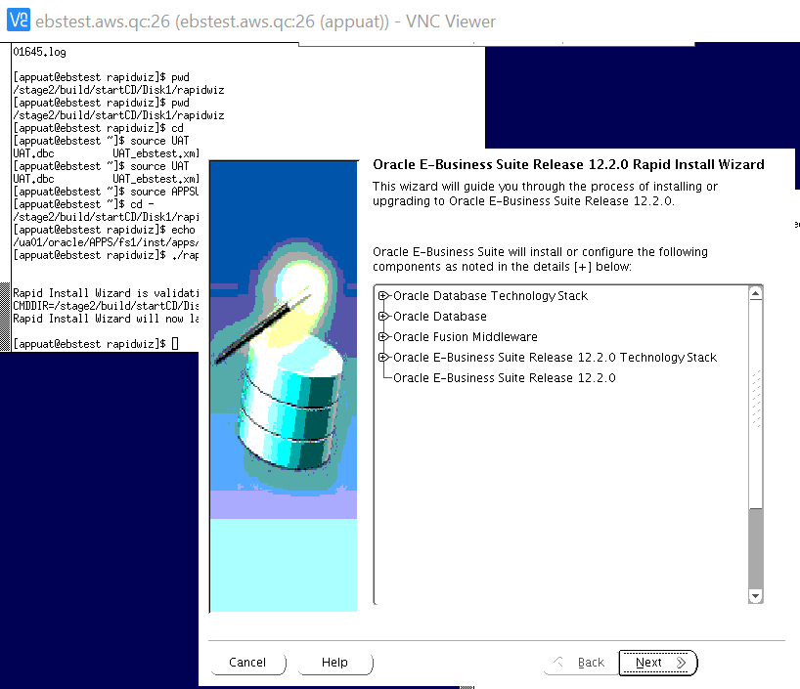
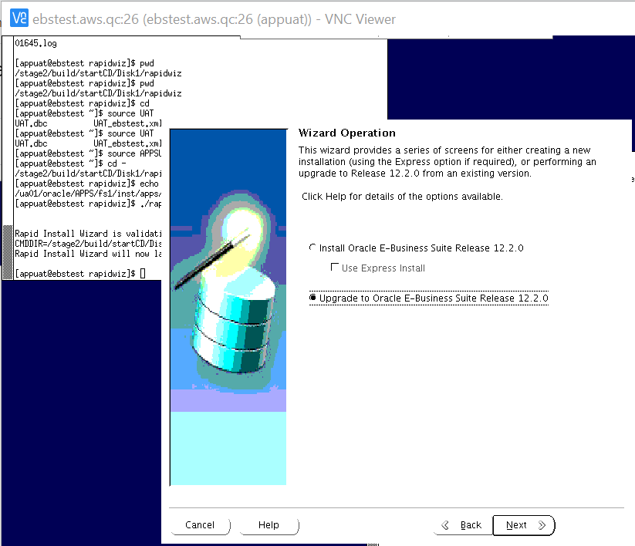
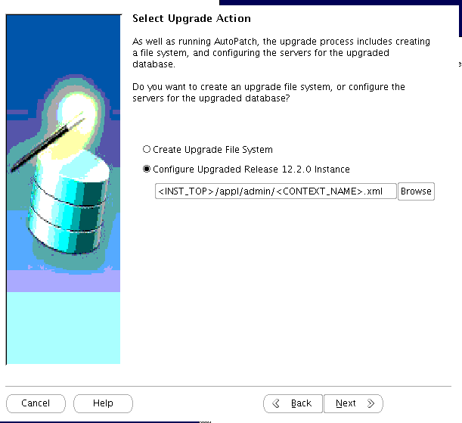
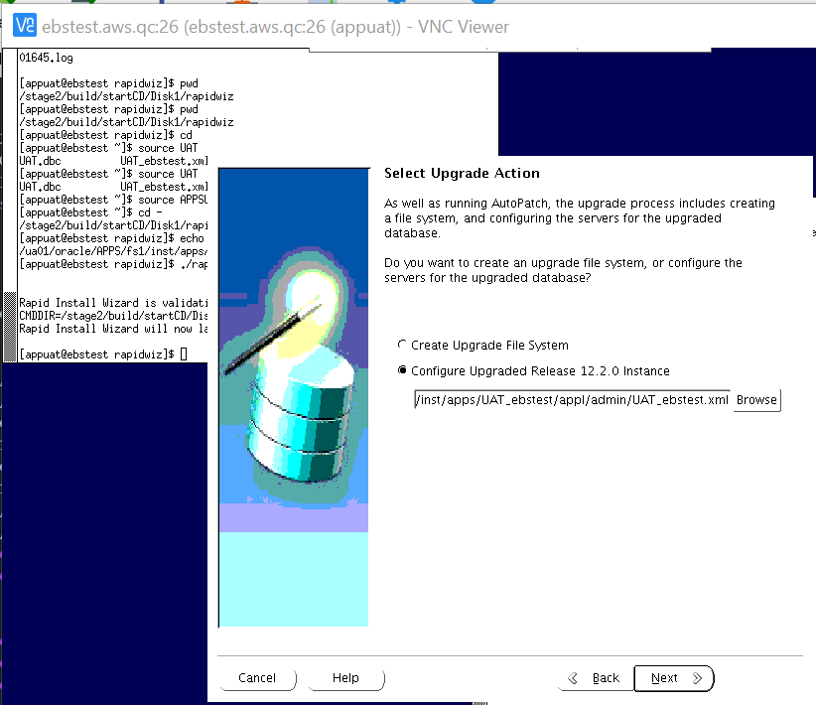
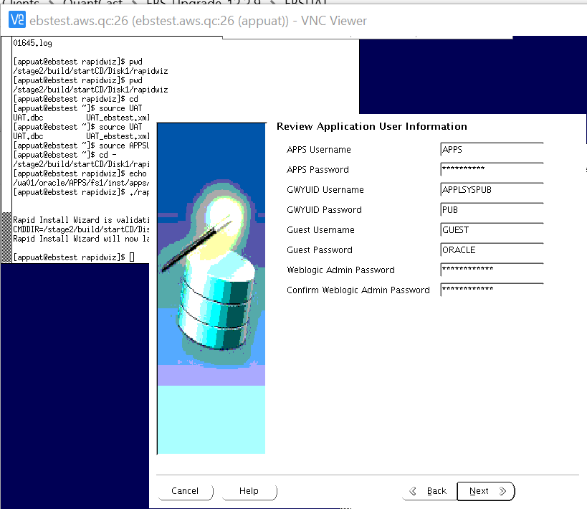
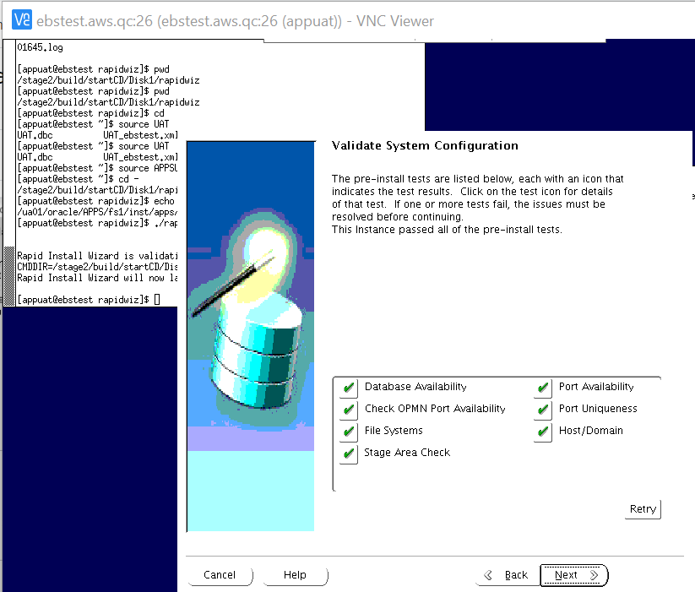
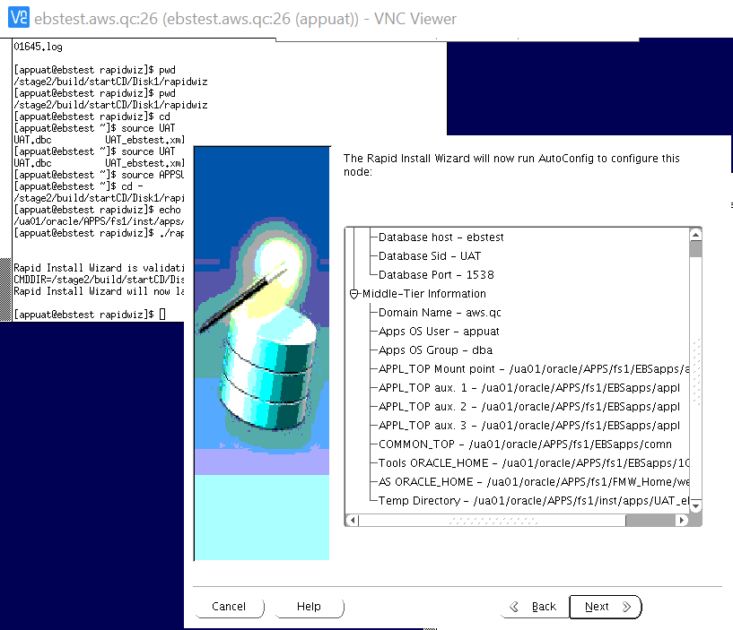
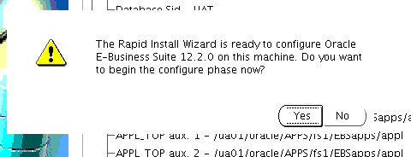
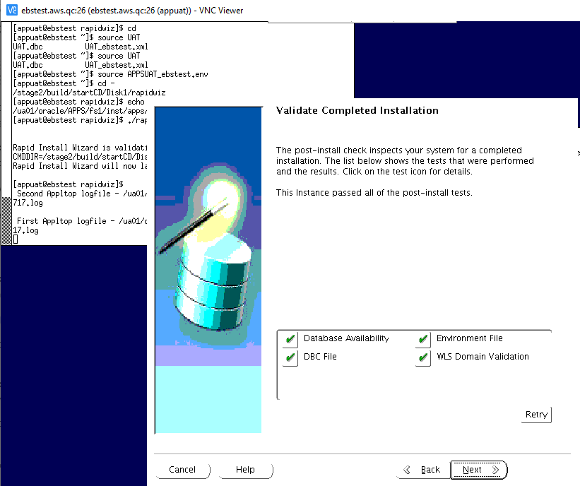
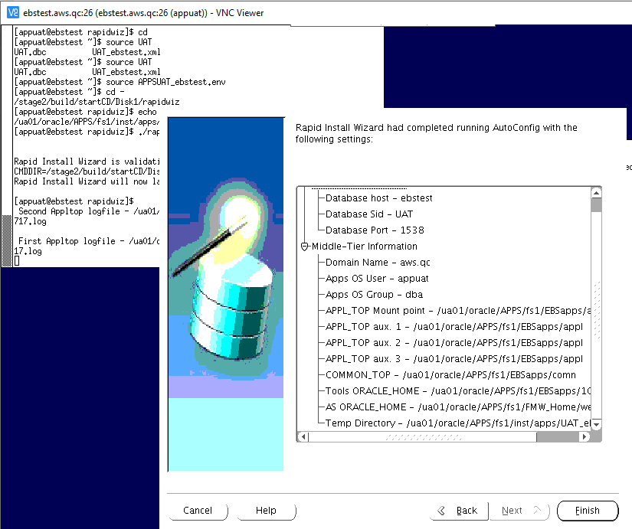

Log Locations:
==========
Second File System logfile - /ua01/oracle/APPS/fs2/inst/apps/CRP_ebscrp/logs/
First File System logfile - /ua01/oracle/APPS/fs1/inst/apps/CRP_ebscrp/logs/

MS2 - Milestone Backup 2

cd /ua4001/oracle/EBSCRP/
nohup tar -czvf /stage/backups/ua4001_EBSCRP_fs1_ms2.tar.gz fs1 &

nohup tar -czvf /stage/backups/oraInventory_ms2.tar.gz oraInventory &

cd /ua4002/oracle/EBSCRP/
nohup tar -czvf /stage/backups/ua4002_EBSCRP_fs1_ms2.tar.gz fs1 &

Bring Down DB and Create a ticket for DB Level0 or Snap backup

Or

create restore point MS2 guarantee flashback database;

ONLINE ENABLEMENT

OLE1 - Apply Online Patching Readiness and GSCC Report patches

Run adgrant.sql from patch 31026891

adpatch options=hotpatch,noprereq,nocompilejsp patchtop=/stage/patches/OLE/31026891 logfile=u31026891.log driver=u31026891.drv workers=8
adpatch options=hotpatch,noprereq,nocompilejsp patchtop=/stage/patches/OLE/30611142 logfile=u30611142.log driver=u30611142.drv workers=8

**************

mkdir -p $LOG_HOME/appl/op
cd $LOG_HOME/appl/op
sqs @$AD_TOP/sql/ADZDPSUM.sql
sqs @$AD_TOP/sql/ADZDPMAN.sql
sqs @$AD_TOP/sql/ADZDPAUT.sql
sqa @$AD_TOP/sql/ADZDDBCC.sql
sqa @$AD_TOP/sql/ADZDEXRPT.sql

mv adzdpsum.txt adzdpsum_pre.txt
mv adzdpman.txt adzdpman_pre.txt
mv adzdpaut.txt adzdpaut_pre.txt
mv adzddbcc.lst adzddbcc_pre.lst
mv adzdexrpt.txt adzdexrpt_pre.txt

***************

OLE2 - Register Custom Schemas

sqa

exec fnd_oracle_user_pkg.load_row('BOLINF', 'CUSTOM', 'INVALID', NULL, 'N', 'B');
exec fnd_oracle_user_pkg.load_row('PORTAL30_PUBLIC', 'CUSTOM', 'INVALID', NULL, 'N', 'B');
exec fnd_oracle_user_pkg.load_row('OHS_ACCNT', 'CUSTOM', 'INVALID', NULL, 'N', 'B');
exec fnd_oracle_user_pkg.load_row('PORTAL30_SSO', 'CUSTOM', 'INVALID', NULL, 'N', 'B');
exec fnd_oracle_user_pkg.load_row('OEMADM', 'CUSTOM', 'INVALID', NULL, 'N', 'B');
exec fnd_oracle_user_pkg.load_row('RAC_ACCNT', 'CUSTOM', 'INVALID', NULL, 'N', 'B');
exec fnd_oracle_user_pkg.load_row('XX_BOLINF_UPS', 'CUSTOM', 'INVALID', NULL, 'N', 'B');
exec fnd_oracle_user_pkg.load_row('WF_ACCNT', 'CUSTOM', 'INVALID', NULL, 'N', 'B');
exec fnd_oracle_user_pkg.load_row('EUL5_US', 'CUSTOM', 'INVALID', NULL, 'N', 'B');
exec fnd_oracle_user_pkg.load_row('RO_BLACKLINE', 'CUSTOM', 'INVALID', NULL, 'N', 'B');
exec fnd_oracle_user_pkg.load_row('PORTAL30', 'CUSTOM', 'INVALID', NULL, 'N', 'B');
exec fnd_oracle_user_pkg.load_row('SA_ACCNT', 'CUSTOM', 'INVALID', NULL, 'N', 'B');
exec fnd_oracle_user_pkg.load_row('XX_BOLINF_UPS2', 'CUSTOM', 'INVALID', NULL, 'N', 'B');

COMMIT;

OLE3 - Perform fix for AD_ZD_PREP invalid object

sqlplus / as sysdba

@?/rdbms/admin/dbmsxdbschmig.sql
@?/rdbms/admin/prvtxdbschmig.plb
@/stage/scripts/adgrants.sql_ole3_64 APPS
GRANT SELECT, UPDATE, DELETE, INSERT on sys.xdb$moveSchemaTab to apps;
grant execute on SYS.XDB_MIGRATESCHEMA to apps;

sqa

alter package AD_ZD_PREP compile body;
alter package AD_ZD_TABLE compile body;

OLE4 - Ensure there are no AD_ZD invalid objects

select owner,object_name,object_type,status from dba_objects where status='INVALID' and object_name like 'AD_ZD%';

OLE5 - Apply the Online Patching Enablement patch

create table SYSTEM.invalids_OLE5 as (select * from dba_invalid_objects);

adpatch options=hotpatch,noprereq,nocompilejsp patchtop=/stage/patches/OLE/13543062 logfile=u13543062.log driver=u13543062.drv workers=8

OLE6 - Run ETCC

alter system set cluster_database=TRUE scope=spfile;

Update ORACLE_HOME details in .bashrc_EBSCRP

Update TNS_ADMIN

srvctl setenv database -d EBSCRP -T TNS_ADMIN="/u01/app/oracle/product/12.1.0.2/EBS/network/admin/EBSCRP"

. $HOME/.bashrc_EBSCRP

srvctl start database -d EBSCRP

Run ETCC on both Db nodes and APP node

EBSCRP

sh /backup/EBSCRP/patches/ETCC/checkDBpatch.sh

mtw-365-uap51

sh /stage/patches/ETCC/checkMTpatch.sh

Run datapatch

sysdba
startup upgrade

cd $ORACLE_HOME/OPatch
./datapatch

SQL> Shut immediate;
SQL> startup

AD & TXK PATCHES

AT1 - Run adgrants.sql
EBSCRP

cd /backup/EBS122/stage
Sqlplus / as sysdba
@adgrants.sql_AT1_65 APPS

AT2 - Start Weblogic Admin Server

{ echo weblogic4crp ; echo Wv7ktyjisy; }|adadminsrvctl.sh start

AT3 - Drop ADX_PRE_AUTOCONFIG Table

sqa @$AD_TOP/patch/115/sql/txkDropAdxPreAutoConfig.sql

AT4 - Apply AD.12 Patch

create table SYSTEM.invalids_AT5 as (select * from dba_invalid_objects);

Delete entries of Source APP node/s from FND_NODES and FND_OAM_CONTEXT_FILES
create table fnd_nodes_bkp1 as select * from fnd_nodes;
create table fnd_oam_context_files_bkp1 as select * from fnd_oam_context_files;
delete from fnd_nodes where NODE_NAME='MTW-365-UAP52';
delete from fnd_nodes where NODE_NAME='MTW-365-UAP53';

delete from fnd_oam_context_files where NODE_NAME= 'mtw-365-uap52';
delete from fnd_oam_context_files where NODE_NAME= 'mtw-365-uap53';

commit;

SQL> exec fnd_conc_clone.setup_clean();

PL/SQL procedure successfully completed.

SQL> commit;

Commit complete.

orabrav@EBSCRP.mtw.itciss.com:EBSCRP > pwd
/u12/oracle/CRP/19c/dbhome_1/appsutil

orabrav@EBSCRP.mtw.itciss.com:EBSCRP > ./scripts/EBSCRP_EBSCRP/adautocfg.sh

[applcrp@ebscrp ~]$ adautocfg.sh

APPLY AD.12 Patch

{ echo Wv7ktyjisy; echo N0t5o3azy; echo weblogic4crp ; } |adop phase=apply patches=30628681 hotpatch=yes patchtop=/stage/patches/DELTA12

AT5 - Apply TXK.12 Merge patches

{ echo Wv7ktyjisy; echo N0t5o3azy; echo weblogic4crp ; } | adop phase=apply patches=30735865,31904550 hotpatch=yes merge=yes patchtop=/stage/patches/DELTA12

AT6 - Stop Weblogic Admin Server

{ echo weblogic4crp ; echo Wv7ktyjisy ;}|adadminsrvctl.sh stop

{ echo weblogic4crp ;} | adnodemgrctl.sh stop

AT7 - Migrate Latest Code to DB node

. /ua4001/oracle/EBSCRP/EBSapps.env run
perl $AD_TOP/bin/admkappsutil.pl
cp /ua4002/oracle/EBSCRP/fs1/inst/apps/EBSCRP_mtw-365-uap51/admin/out/appsutil.zip /stage/scripts/

sqa

create table xx_backup.fnd_nodes_bkp1 as select * from fnd_nodes;
create table xx_backup.fnd_oam_context_files_bkp1 as select * from fnd_oam_context_files;
exec fnd_conc_clone.setup_clean();
commit;

On the Database Tier (as the ORACLE user):
Copy or SCP the appsutil.zip file to $ORACLE_HOME on all the RAC nodes

cd $ORACLE_HOME
mv appsutil appsutil_at9
unzip -o /stage/scripts/appsutil.zip

cd $ORACLE_HOME/appsutil
cp /backup/EBSCRP/patches/jre-7u211-linux-x64.tar .
tar -xvf jre-7u211-linux-x64.tar
mv jre1.7.0_211 jre

AT8 - Build Context File on DB node

cd $ORACLE_HOME/appsutil/bin
perl adbldxml.pl jtop=$ORACLE_HOME/jdk

Enter Database Service Name: EBSCRP

Enter the value for Display Variable: EBSCRP.mtw.itciss.com:0

AT9 - Run Autoconfig on DB node

cd $ORACLE_HOME/appsutil/bin
./adconfig.sh contextfile=/u12/oracle/CRP/19c/dbhome_1/appsutil/CRP_ebscrp.xml

AT10 - Run Autoconfig on Apps Tier

adautocfg.sh

MILESTONE BACKUP 3

cd /ua4001/oracle/EBSCRP/
nohup tar -czvf /stage/backups/ua4001_EBSCRP_fs1_ms3.tar.gz fs1 &

nohup tar -czvf /stage/backups/oraInventory_ms3.tar.gz oraInventory &

cd /ua4002/oracle/EBSCRP/
nohup tar -czvf /stage/backups/ua4002_EBSCRP_fs1_ms3.tar.gz fs1 &

Bring Down DB and create a ticket for DB Level0 or snap backup

Or

Create restore point MS2 guarantee flashback database;

12.2.9 UPGRADE

RUP1 - Apply 12.2.9 Upgrade Patch in Downtime Mode and Interactive Mode

create table SYSTEM.invalids_rup1 as (select * from dba_invalid_objects);

Use Below Command only to apply the patch:

adop phase=apply apply_mode=downtime

Applying patch interactively.

Enter command line parameters followed by <Return>, or just <Return> for default processing:

Filename [adpatch.log] : u28840850.log

Num Workers = 32.
Options = "hotpatch".

You can be notified by email if a failure occurs.
Do you wish to activate this feature [No] ?

Please enter the batchsize [1000] : 30000

The default directory is [/stage/1229/28840850] :

Please enter the name of your AutoPatch driver file : u28840850.drv

Do you wish to apply this patch now [No] ? Yes

Patch fails here

RUP2 - Apply 1220 Online Help Patch

create table SYSTEM.invalids_RUP2 as (select * from dba_invalid_objects);

{ echo Wv7ktyjisy; echo N0t5o3azy; echo weblogic4crp; } | adop phase=apply patchtop=$AU_TOP/patch/115 patches=driver:u10201000.drv options=nocopyportion,nogenerateportion,forceapply hotpatch=yes workers=16

RUP3 - Apply 1229 Online Help Patch

{ echo Wv7ktyjisy; echo N0t5o3azy; echo weblogic4crp; } | adop phase=apply patches=28840900 hotpatch=yes patchtop=/stage/1229 workers=16

RUP4 - Apply OA Framework (FWK) Release 12.2.9 Bundle 7 Patch

{ echo Wv7ktyjisy; echo N0t5o3azy; echo weblogic4crp; } | adop phase=apply patches=32130874 apply_mode=downtime patchtop=/stage/OA_FWK workers=16

RUP5 - Apply EBS JAN 2021 CPU Patch

cd /stage/scripts
sysdba
@adgrants.sql_rup5_56 APPS

- JAN 2021 CPU Patch

{ echo Wv7ktyjisy; echo N0t5o3azy; echo weblogic4crp; } | adop phase=apply patches=32071646 apply_mode=downtime patchtop=/stage/CPU_EBS workers=16

- Post CPU Patches

{ echo Wv7ktyjisy; echo N0t5o3azy; echo weblogic4crp; } | adop phase=apply patches=32117360,32004048 apply_mode=downtime patchtop=/stage/CPU_EBS workers=16

{ echo Wv7ktyjisy; echo N0t5o3azy; echo weblogic4crp; } | adop phase=apply patches=31745969,31206584,30980446,30367367,25229413,26282050,29662975 apply_mode=downtime merge=yes patchtop=/stage/CPU_EBS workers=16

RUP6 - Apply Post patches

create table SYSTEM.invalids_RUP6 as (select * from dba_invalid_objects);

MILESTONE BACKUP 4

cd /ua4001/oracle/EBSCRP/
nohup tar -cvf /stage/CRP/backup/ua01_EBSCRP_fs1_ms4.tar.gz fs1 &

cd /ua4002/oracle/EBSCRP/
nohup tar -cvf /stage/CRP/backup/fininst_EBSCRP_fs1_ms4.tar.gz fs1 &

cd /ua01/
nohup tar -cvf /stage/CRP/backup/oraInventory_ms4.tar.gz oraInventory &

Bring Down DB and Create a ticket for DB Level0 or Snap backup
Or

create restore point MS4 guarantee flashback database;

JDK UPGRADE

JDK1 - Main JDK Upgrade
create table SYSTEM.invalids_JDK1 as (select * from dba_invalid_objects);

cd $COMMON_TOP/util
mv jdk32 jdk32_old
mv jdk64 jdk64_old
tar -xvf /stage/JDK_JRE/jdk-7u291-linux-i586.tar.gz
mv jdk1.7.0_291 jdk32
tar -xvf /stage/JDK_JRE/jdk-7u291-linux-x64.tar.gz
mv jdk1.7.0_291 jdk64

JDK2 - Update JDK Configuration
Bring up Weblogic Admin Server

adadminsrvctl.sh start
$FND_TOP/bin/txkrun.pl –script =SetJDKCfg

Enter the full path of new 64-bit JDK: /ua01/oracle/APPS/fs1/EBSapps/comn/util/jdk64
Enter the full path of new 32-bit JDK: /ua01/oracle/APPS/fs1/EBSapps/comn/util/jdk32

JDK3 - Run autoconfig
Bring down Admin Server and node manager.

adadminsrvctl.sh stop
adnodemgrctl.sh stop

adautocfg.sh

JDK4 - WebTier JDK Upgrade - 64 Bit
cd $FMW_HOME/webtier

mv jdk jdk_old
tar -xvf /stage/JDK_JRE/jdk-7u291-linux-x64.tar.gz
mv jdk1.7.0_291 jdk

JDK5 - 1012 Home JDK Upgrade-32 bit

cd $ORACLE_HOME
mv jdk jdk_old
tar -xvf /stage/JDK_JRE/jdk-7u291-linux-i586.tar.gz
mv jdk1.7.0_291 jdk

JDK6 - Relink Forms

cd $ORACLE_HOME/forms/lib
make -f ins_forms.mk sharedlib install

JDK7 - Relink Reports

cd $ORACLE_HOME/reports/lib
make -f ins_reports.mk install

JDK8 - Allow Unrestricted access for JSPs

sqa

SET SERVEROUTPUT ON
DECLARE
stat BOOLEAN;
BEGIN
DBMS_OUTPUT.DISABLE;
DBMS_OUTPUT.ENABLE (100000);
stat := fnd_profile.SAVE ('FND_SEC_ALLOW_JSP_UNRESTRICTED_ACCESS', 'Yes' , 'SITE');
IF stat
THEN
DBMS_OUTPUT.put_line ('Stat = TRUE - profile FND_SEC_ALLOW_JSP_UNRESTRICTED_ACCESS updated');
ELSE
DBMS_OUTPUT.put_line ('Stat = FALSE - profile FND_SEC_ALLOW_JSP_UNRESTRICTED_ACCESS NOT updated');
END IF;
COMMIT;
END;
/

JRE UPGRADE

JRE1 - Apply the JRE Interoperability Patch

{ echo Wv7ktyjisy ; echo N0t5o3azy ; echo weblogic4crp ; } | adop phase=apply patches=26100397 apply_mode=downtime patchtop=/stage/build/patches workers=16

JRE2 - Copy Latest JRE

cd $COMMON_TOP/webapps/oacore/util/javaplugin/

cp /stage/JDK_JRE/jre- -windows-i586.exe .
mv jre-8u281-windows-i586.exe j2se18281.exe

JRE3 - Update JRE Configuration

$FND_TOP/bin/txkSetPlugin.sh 18281

Verify JRE Version:

grep -i plugin $CONTEXT_FILE

Post Upgrade Steps

PUG1A - Update Context File for below parameters

Update below values in Context File:

JWS:

<config_option type="techstack" oa_var="s_forms_launch_method">jws</config_option>

Shared File system:

<shared_file_system oa_var="s_shared_file_system">true</shared_file_system>

WF Mailer:

<hostname oa_var="s_javamailer_imaphost">mtw-365-mail02</hostname>
<domain oa_var="s_javamailer_imapdomainname">mtw.itciss.com</domain>
<username oa_var="s_wf_admin_role">FND_RESP|FND|FNDWF_ADMIN|STANDARD</username>
<username oa_var="s_javamailer_reply_to">wfEBSCRP@mtw-365-mail02.mtw.itciss.com</username>
<username oa_var="s_javamailer_imap_user">wfEBSCRP</username>

Login URL:

<activewebport oa_var="s_active_webport" oa_type="DUP_PORT" base="8000" step="1" range="-1" label="Active Web Port">80</activewebport>
<externURL oa_var="s_external_url">http://EBSCRP.mtw.itciss.com</externURL>
<webentryhost oa_var="s_webentryhost">EBSCRP</webentryhost>
<login_page oa_var="s_login_page">http://EBSCRP.mtw.itciss.com/OA_HTML/AppsLogin</login_page>

Server Admin

<ohs_serveradmin oa_var="s_ohs_serveradmin">applCRP@itciss.com</ohs_serveradmin>

APPLPTMP

<APPLPTMP oa_var="s_applptmp" osd="UNIX">/uu4001/utl_file_dir</APPLPTMP>

PUG1 - Copy Custom tops from 1213

cd $AU_TOP/resource

cp -Rp /stage/backups/ua4001/oracle/EBSCRP_1213/apps/apps_st/appl/au/12.0.0/resource/XX* .

cp -Rp /stage/backups/ua4001/oracle/EBSCRP_1213/apps/apps_st/appl/au/12.0.0/resource/CUSTOM* .

cd $APPL_TOP

cp -Rp /stage/backups/ua4001/oracle/EBSCRP_1213/apps/apps_st/appl/xbol .

cp -Rp /stage/backups/ua4001/oracle/EBSCRP_1213/apps/apps_st/appl/xxcao .

cd $JAVA_TOP

cp -Rp /stage/backups/ua4001/oracle/EBSCRP_1213/apps/apps_st/comn/java/classes/com .

cp -Rp /stage/backups/ua4001/oracle/EBSCRP_1213/apps/apps_st/comn/java/classes/COM .

cp -Rp /stage/backups/ua4001/oracle/EBSCRP_1213/apps/apps_st/comn/java/classes/crysec .

cp -Rp /stage/backups/ua4001/oracle/EBSCRP_1213/apps/apps_st/comn/java/classes/EDU .

cp -Rp /stage/backups/ua4001/oracle/EBSCRP_1213/apps/apps_st/comn/java/classes/ewttdg .

cp -Rp /stage/backups/ua4001/oracle/EBSCRP_1213/apps/apps_st/comn/java/classes/javax .

cp -Rp /stage/backups/ua4001/oracle/EBSCRP_1213/apps/apps_st/comn/java/classes/jndi .

cp -Rp /stage/backups/ua4001/oracle/EBSCRP_1213/apps/apps_st/comn/java/classes/junit .

cp -Rp /stage/backups/ua4001/oracle/EBSCRP_1213/apps/apps_st/comn/java/classes/model .

cp -Rp /stage/backups/ua4001/oracle/EBSCRP_1213/apps/apps_st/comn/java/classes/netcharts .

cp -Rp /stage/backups/ua4001/oracle/EBSCRP_1213/apps/apps_st/comn/java/classes/netscape .

cp -Rp /stage/backups/ua4001/oracle/EBSCRP_1213/apps/apps_st/comn/java/classes/org .

cp -Rp /stage/backups/ua4001/oracle/EBSCRP_1213/apps/apps_st/comn/java/classes/sun .

cp -Rp /stage/backups/ua4001/oracle/EBSCRP_1213/apps/apps_st/comn/java/classes/tdg .

cp -Rp /stage/backups/ua4001/oracle/EBSCRP_1213/apps/apps_st/comn/java/classes/tomsawyer .

cp -Rp /stage/backups/ua4001/oracle/EBSCRP_1213/apps/apps_st/comn/java/classes/unittest .

cp -Rp /stage/backups/ua4001/oracle/EBSCRP_1213/apps/apps_st/comn/java/classes/view .

cp -Rp /stage/backups/ua4001/oracle/EBSCRP_1213/apps/apps_st/comn/java/classes/watt .

cp -Rp /stage/backups/ua4001/oracle/EBSCRP_1213/apps/apps_st/comn/java/classes/xbol .

PUG2 - Prepare Custom Env File

cd $INST_TOP/appl/admin
cp /stage/scripts/customEBSCRP_mtw-365-uap51.env .

mkdir -p "/ua01/oracle/APPS/fs1/EBSapps/comn/EBSCRP_Interface"

PUG4 - Run Autoconfig
mtw-365-uap51

adadminsrvctl.sh stop
adnodemgrctl.sh stop

EBSCRP
sqlplus / as sysdba
SQL> shut immediate;
SQL> startup;

mtw-365-uap51

perl $AD_TOP/bin/admkappsutil.pl
Copy appsutil.zip to /stage/scripts

EBSCRP

. .bash_profile
cd $ORACLE_HOME
tar -czvf appsutil_b4_pug4.tar.gz appsutil/
cp /stage/scripts/appsutil_pug4.zip $ORACLE_HOME
cd $ORACLE_HOME
unzip -o appsutil_pug4.zip
EBSCRP

$ORACLE_HOME/appsutil/bin/adconfig.sh contextfile=$ORACLE_HOME/appsutil/EBSCRP1_EBSCRP.xml -appspass=Wv7ktyjisy
mtw-365-uap51

adautocfg.sh
Remove the *deny* entry from $EBS_DOMAIN_HOME/config/config.xml

PUG5 - Upload Patch Context File to DB
UPDATE THE JDBC URL in the patch context file and upload as below:

$ADJVAPRG oracle.apps.ad.autoconfig.oam.CtxSynchronizer \
action=upload \
contextfile=/ua4002/oracle/EBSCRP/fs2/inst/apps/EBSCRP_mtw-365-uap51/appl/admin/EBSCRP_mtw-365-uap51.xml \
logfile=/tmp/EBSCRP_patchctxupload.log

PUG6 - Copy Logo Files
Copy Logo Files to $OA_MEDIA

cd $OA_MEDIA

cp -Rp /stage/backups/ua4001/oracle/EBSCRP_1213/apps/apps_st/comn/java/classes/oracle/apps/media/xx* .

PUG7 - XDO Configuration

PUG8 - Perform ADADMIN Activities

- Compile invalid objects

EXECUTE SYS.UTL_RECOMP.RECOMP_PARALLEL;

- Force Generate Jar files from ADADMIN
- Reload Jar files to Database from ADADMIN

perl $FND_TOP/patch/115/bin/ojspCompile.pl --compile --flush -p 10

- Generate all Messages
- Generate forms
- Generate reports,
- Re-Create Grants and Synonyms,
- Compile Flexfields
- Compile Apps Schema

create table system.invalids_pug9x as select * from dba_invalid_objects;

PUG9 - Re-enable the Custom triggers
sqa
alter trigger APPS.XXQC_AR_BILLING_STG_T enable;

-- SYS jobs
exec dbms_scheduler.enable('PURGE_LOG');
exec dbms_scheduler.enable('GATHER_SYS_STATS_JOB');
exec dbms_scheduler.enable('ORA$AUTOTASK_CLEAN');
exec dbms_scheduler.enable('DRA_REEVALCRPE_OPEN_FAILURES');
exec dbms_scheduler.enable('BSLN_MAINTAIN_STATS_JOB');
exec dbms_scheduler.enable('RSE$CLEAN_RECOVERABLE_SCRIPT');
exec dbms_scheduler.enable('SM$CLEAN_AUTO_SPLIT_MERGE');
exec dbms_scheduler.enable('CLEANUP_NON_EXIST_OBJ');
exec dbms_scheduler.enable('PMO_DEFERRED_GIDX_MAINT_JOB');
exec dbms_scheduler.enable('CLEANUP_ONLINE_IND_BUILD');
exec dbms_scheduler.enable('CLEANUP_TAB_IOT_PMO');
exec dbms_scheduler.enable('CLEANUP_TRANSIENT_TYPE');
exec dbms_scheduler.enable('CLEANUP_TRANSIENT_PKG');
exec dbms_scheduler.enable('CLEANUP_ONLINE_PMO');
exec dbms_scheduler.enable('FILE_SIZE_UPD');

APPS user jobs:

SQL> BEGIN
FOR J IN (SELECT * FROM user_jobs)
LOOP
dbms_job.broken( J.job, FALSE);
END LOOP;
END;
/

select schema_user, 'exec dbms_job.broken('||job||',FALSE);' from dba_jobs where BROKEN='Y' order by schema_user;

PUG9.1 - Custom JAR deployment
cd $JAVA_TOP
zip -r customall.zip xxcustom xxaug oracle/apps/ben/selfservice/cwb/webui/xx*
adjava oracle.apps.ad.jri.adjmx -areas customall.zip -outputFile customall.jar -jar ebsjarsign 1 CUST jarsigner -storePass puneet -keyPass myxuan

PUG9.2 – Update WF Mailer status and startup mode
============
UPDATE fnd_svc_components
SET
component_status = 'DEACTIVATED_SYSTEM'
WHERE
component_id = (
SELECT
component_id
FROM
fnd_svc_components
WHERE
component_name = 'Workflow Notification Mailer'
);
============
UPDATE fnd_svc_components fsc
SET
fsc.startup_mode = 'MANUAL'
WHERE
fsc.component_name = 'Workflow Notification Mailer';
COMMIT;

PUG10 - Bring up Apps Services
create table SYSTEM.invalids_PUG10 as (select * from dba_invalid_objects);
{ echo apps ; echo Wv7ktyjisy ; echo weblogic4crp; } | sh $ADMIN_SCRIPTS_HOME/adstrtal.sh -nopromptmsg

PUG11 - Perform Sanity Tests
Check Login,
Forms access
Concurrent Request Log and Out files are opening Fine.

MILESTONE ADHOC

Stop all application services
{ echo apps ; echo Wv7ktyjisy ; echo weblogic4crp ; } | sh $ADMIN_SCRIPTS_HOME/adstpall.sh -nopromptmsg

Shut immediate
Startup mount

[oracrp@ebscrp PUG11]$ ls -ltrh
total 24K
-rwxrwxrwx 1 applcrp dba 1.7K Jul 6 18:41 rman_bkp_pug11_CRP.sh
-rwxrwxrwx 1 applcrp dba 584 Jul 6 18:49 backup_apps_pug11.sh
-rwxrwxrwx 1 applcrp dba 151 Jul 6 18:49 backup_oh_pug11.sh
drwxr-x--- 2 oracrp dba 4.0K Jul 6 18:51 OH
drwxr-xr-x 2 applcrp dba 4.0K Jul 6 18:54 APPS
drwxr-x--- 2 oracrp dba 4.0K Jul 6 18:54 DB
[oracrp@ebscrp PUG11]$ sh backup_oh_pug11.sh

[oracrp@ebscrp PUG11]$ nohup sh rman_bkp_pug11_CRP.sh >>/stage/DB_APPS_BKP_P3/PUG11/DB/rman_full_bkp_CRP_07JUL2021_nohup.log &
After rman backup is completed . Cross verify and perform this step.
[oracrp@ebscrp DB]$ grep -i "/u12/oracle/CRP/19c/dbhome_1/dbs" rman_full_bkp_CRP_07JUL2021_PUG11.log
piece handle=/u12/oracle/CRP/19c/dbhome_1/dbs/c-2456528033-20210706-00 comment=NONE

[oracrp@ebscrp DB]$ cp -rp /u12/oracle/CRP/19c/dbhome_1/dbs/c-2456528033-20210706-00 .

[applcrp@ebscrp PUG11]$ sh backup_apps_pug11.sh

Bring Down DB and Create a ticket for DB Level0 or Snap backup
Or
create restore point PUG11 guarantee flashback database;

PUG12 - Run FS_CLONE ⇒ COMPLETED on QC EBSCRP

{ echo apps ; echo Wv7ktyjisy ; echo weblogic4crp ; } | sh $ADMIN_SCRIPTS_HOME/adstrtal.sh -nopromptmsg

{ echo Wv7ktyjisy ; echo N0t5o3azy ; echo weblogic4crp ; } | adop phase=fs_clone

[ERROR] [CLEANUP 1:1 ddl_id=5287] ORA-04020: deadlock detected while trying to lock object SYS.DBMS_SYS_SQL SQL: begin sys.ad_grants.cleanup; end;
Refer : Doc ID 2424333.1

PUG13 - Run adpreclone on both Run and Patch FS
cd $ADMIN_SCRIPTS_HOME
adadminsrvctl.sh start
cd $ADMIN_SCRIPTS_HOME/
perl adpreclone.pl appsTier

. /ua4001/oracle/EBSCRP/EBSapps.env patch
adadminsrvctl.sh start forcepatchfs
cd $ADMIN_SCRIPTS_HOME/
perl adpreclone.pl appsTier

PUG14 - Take Full Instance Backup
create restore point ms5 guarantee flashback database;
cd /ua01/
nohup tar -cvf /stage/CRP/backup/EBSCRP_ua01_ms5.tar.gz EBSCRP &
cd /fininst/
nohup tar -cvf /stage/CRP/backup/EBSCRP_fininst_ms5.tar.gz EBSCRP &
cd /ua01/
nohup tar -cvf /stage/CRP/backup/EBSCRP_oraInventory_ms5.tar.gz oraInventory &

NA02 - Enable Passwordless SSH
$AD_TOP/patch/115/bin/txkRunSSHSetup.pl enablessh -contextfile=$CONTEXT_FILE -hosts=mtw-365-uap51,mtw-365-uap52
- needs SSH password for applbrav user.
Or manually enable SSH
ssh-keygen -t rsa
Press Enter when prompted for Passphrase.
Copy the public key on one node to the file “authorized_keys” on the other node.

NA20 - Run adpreclone.pl on both Run and Patch FS
cd $ADMIN_SCRIPTS_HOME/
perl adpreclone.pl appsTier

NA21 - Compile Invalids
Compile invalid objects

EXECUTE SYS.UTL_RECOMP.RECOMP_PARALLEL;

MS6 - Final Milestone Backup
cd /ua01/
nohup tar -cvf /stage/CRP/backup/EBSCRP_ua01_ms6.tar.gz EBSCRP &
cd /fininst/
nohup tar -cvf /stage/CRP/backup/EBSCRP_fininst_ms6.tar.gz EBSCRP &
cd /ua01/
nohup tar -cvf /stage/CRP/backup/EBSCRP_oraInventory_ms6.tar.gz oraInventory &

Bring Down DB and Create a ticket for DB Level0 or Snap backup
Or
create guarantee restore point MS6 flashback database;

